# Lab 23

Instructor: Sidra Khatoon

E-mail: skhatoon[@uit.edu](mailto:ad@uit.edu)

# Objective

# The objective of lab is to used to store login Information using Shared Preferences.

**Student Information**

|  |  |
| --- | --- |
| **Student Name** |  |
| **Student ID** |  |
| **Date** |  |

**Assessment**

|  |  |
| --- | --- |
| **Marks Obtained** |  |
| **Remarks** |  |
| **Signature** |  |

# Objective

# The objective of lab is to used to store login Information using Shared Preferences.

# Instructions

You have to perform the following tasks yourselves. Raise your hand if you face any difficulty in understanding and solving these tasks. **Plagiarism** is an abhorrent practice and you should not engage in it.

# How to Submit?

Submit lab work using Teams.

# Flutter – Shared Preferences to Keep User Logged In

If you implement Sign-in and Sign-out features in your Android Application. Then you must need the user logged in if the user previously logged in and the user logged out if the user is previously logged-out.

Now we are giving a simple idea of how to do that, If we create a bool variable to hold the state of the user logged in or logged out. If the user logged in we can store true in the variable and if the user is not logged in we can store false in the variable. Now again problem is that this variable is created at the time the application is running and destroyed when the application is not running, Now how to fetch this value to check whether the user logged in or not?

Shared Preferences do that work, Shared Preferences is the short value data storage that persists or save the small data into the device storage.  Now all things are clear, Fetch every time value of the variable and Navigate the screen according to this variable.

# Step By Step Implementation:

**1: Create a New Project in VS Code**

Create a new project with 3 screen on VS code. First screen is splash Screen, second is for login and third for home screen. If user login information is saved then after splash we are navigating to the homescreen.

**2: Add the Package into the pubspec.yaml file**

**Run this command:**

With Flutter:

$ flutter pub add shared_preferences

This will add a line like this to your package’s pubspec.yaml (and run an implicit flutter pub get):

dependencies:

shared_preferences: ^2.0.15

**3: Implementaion**

**Create three screens of our basic app. 1st screen for splashscreen, 2nd for login and 3rd for home screen**

**First we edit initstate in splash screen class**

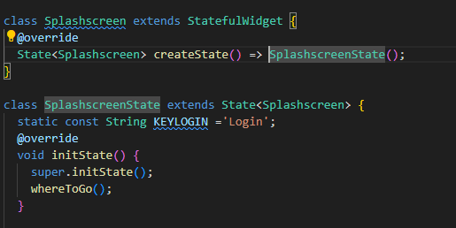

**We have created a function of whereToGo which is decide the navigation of page.**

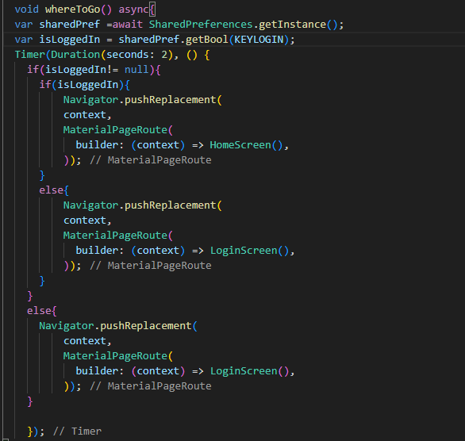

**Now we have to change the code on login screen in button class.**

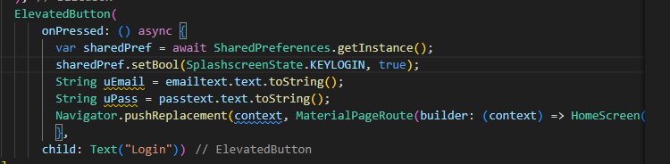

**By using shared preferences we can save login information. For logout we add a button for logout on Home screen.**

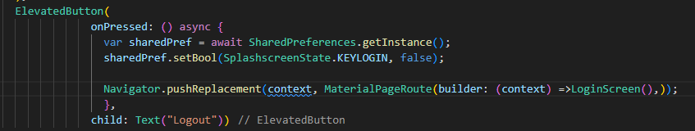

**Assessment:**

Q1: Explain their purpose and give a use case for keeping a user logged in.

Q2: Is Shared Preferences a secure way to store sensitive data? Why or why not?

Q3: How would you structure the logic to check if a user is already logged in when the app starts?